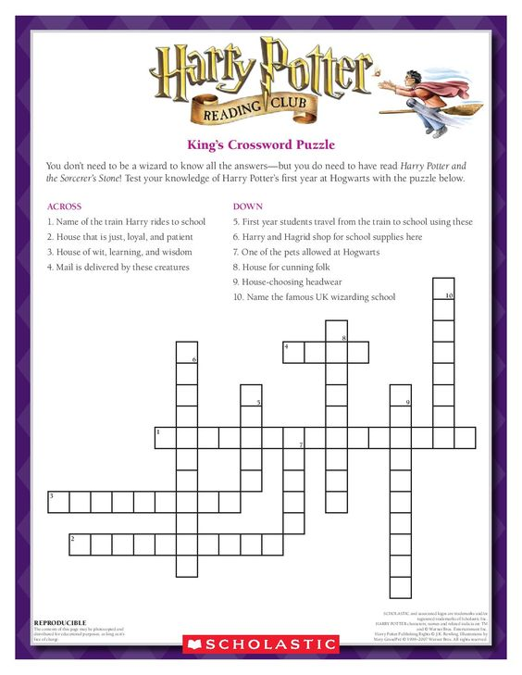
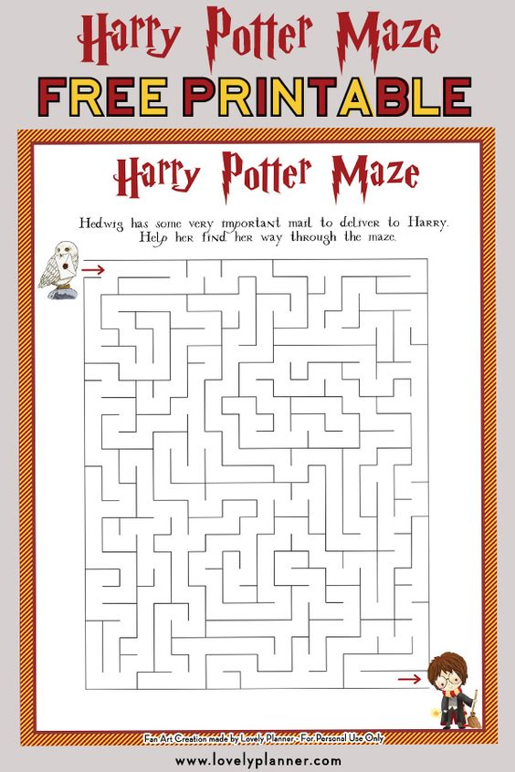

Which creatures pull the carriages that take students from the Hogwarts Express to the Castle?
HIPPOGRIFFS
THESTRALS
CENTAURS
MANTICORES

What is the name of the room Harry uses to teach Dumbledore's Army?
THE RESTRICTED SECTION OF THE LIBRARYTHE
GIRLS BATHROOM ON THE FIRST FLOOR
THE PREFECT'S BATHROOMTHE
ROOM OF REQUIREMENT

What is the name of the book Hermione supposes Voldemort used to learn about Horcruxes?
MAGIK MOSTE EVIL
SECRETS OF THE DARKEST ART
A GUIDE TO MEDIEVAL SORCERY
MOSTE POTENTE POTIONS

In order they taught, who were the six Defence Against the Dark Arts professors who taught Harry at Hogwarts?
QUIRRELL, LOCKHART, LUPIN, MOODY, UMBRIDGE, SNAPE
QUIRRELL, LOCKHART, LUPIN, MOODY, UMBRIDGE, SLUGHORN
QUIRRELL, LOCKHART, LUPIN, UMBRIDGE, MOODY, SNAPE
QUIRRELL, LOCKHART, LUPIN, MOODY, SNAPE, CARROW

Slughorn teaches his students that Amortentia smells different to each person. What food does Harry smell?
PUMPKIN JUICE
MRS WEASLEY'S FUDGE
LEMON DROPS
TREACLE TART

Where is the Slytherin common room located?
NEXT TO THE KITCHENS
IN THE WEST TOWER
THE DUNGEONS
BELOW THE GREAT HALL

How many staircases does Hogwarts have?
142
143
163
152

Which Hogwarts professor was rumored to be a dueling champion in their youth?
MINERVA MCGONAGALL
SEVERUS SNAPE
FILIUS FLITWICK
HORACE SLUGHORN

Who is the Hufflepuff house ghost?
CUTHBERT BINNS
SIR PATRICK DELANEY-PODMORE
THE FAT FRIAR
THE GREY LADY

Who was the headmaster of Hogwarts when the Chamber of Secrets was opened for the first time?
ARMANDO DIPPET
ALBUS DUMBLEDORE
PHINEAS NIGELLUS BLACK
BRUTUS SCRIMGEOUR

Which creatures pull the carriages that take students from the Hogwarts Express to the Castle?
HIPPOGRIFFS
THESTRALS
CENTAURS
MANTICORES

What is the name of the room Harry uses to teach Dumbledore's Army?
THE RESTRICTED SECTION OF THE LIBRARYTHE
GIRLS BATHROOM ON THE FIRST FLOOR
THE PREFECT'S BATHROOMTHE
ROOM OF REQUIREMENT

What is the name of the book Hermione supposes Voldemort used to learn about Horcruxes?
MAGIK MOSTE EVIL
SECRETS OF THE DARKEST ART
A GUIDE TO MEDIEVAL SORCERY
MOSTE POTENTE POTIONS

In order they taught, who were the six Defence Against the Dark Arts professors who taught Harry at Hogwarts?
QUIRRELL, LOCKHART, LUPIN, MOODY, UMBRIDGE, SNAPE
QUIRRELL, LOCKHART, LUPIN, MOODY, UMBRIDGE, SLUGHORN
QUIRRELL, LOCKHART, LUPIN, UMBRIDGE, MOODY, SNAPE
QUIRRELL, LOCKHART, LUPIN, MOODY, SNAPE, CARROW

Slughorn teaches his students that Amortentia smells different to each person. What food does Harry smell?
PUMPKIN JUICE
MRS WEASLEY'S FUDGE
LEMON DROPS
TREACLE TART

Where is the Slytherin common room located?
NEXT TO THE KITCHENS
IN THE WEST TOWER
THE DUNGEONS
BELOW THE GREAT HALL

How many staircases does Hogwarts have?
142
143
163
152

Which Hogwarts professor was rumored to be a dueling champion in their youth?
MINERVA MCGONAGALL
SEVERUS SNAPE
FILIUS FLITWICK
HORACE SLUGHORN

Who is the Hufflepuff house ghost?
CUTHBERT BINNS
SIR PATRICK DELANEY-PODMORE
THE FAT FRIAR
THE GREY LADY

Who was the headmaster of Hogwarts when the Chamber of Secrets was opened for the first time?
ARMANDO DIPPET
ALBUS DUMBLEDORE
PHINEAS NIGELLUS BLACK
BRUTUS SCRIMGEOUR

